Western Punjab College of Law

LL.B Part I

Notes: Introduction to Philosophy of Law

(Handout no. 3)

***Kinds of law***

Sir John Salmond refers to eight kinds of law:

1. Imperative law

2. Physical or scientific law

3. Natural or moral law

4. Conventional law

5. Customary law

6. Practical or technical law

7. International law

8. Civil law

1. **Imperative law:**

Imperative law means a rule of action imposed upon by some authority which enforces obedience to it. In other words it is a command enforced by some superior power either physically or in any other form of compulsion.

There are two kinds of imperative law:

i). Divine laws

ii). Human laws

Divine laws consist of the commands imposed by God upon men either by threats of Punishment or by hope of his blessings.

Human laws are the laws by analogy. Sir John Salmond classifies Human Laws into four sub classes:

* Imperative law imposed and enforced by State is called “Civil law”
* Imperative law imposed and enforced by members of society is “Moral law”
* Those imposed and enforced by different institutions or autonomous bodies like Universities, airline companies etc they are called “Autonomic law”
* Those imposed upon States by the society of States are called

“ International law”

1. **Physical or scientific law:**

Physical laws are the expressions of the Uniformities of nature and General Principles Expressing the Regularity, and Harmony observable in the activities and operations of the universe. They are not the creation of men and cannot be changed by them. Human laws change from time to time and from country to country but physical laws are invariable forever. The uniform actions of human beings, such as law of psychology, also fall into this class they express not what man ought to do, but what they do.

1. **Practical or Technical law:-**

It consists of Principles and rules for the attainment of certain ends e.g. laws of health, laws of architecture. These rules guide us as to what we ought to do in order to attain certain ends.

1. **Natural or Moral law:-**

It has various other names such as, “the Moral law” “Divine law” “God Law” ‘universal or eternal law and “law of reason” etc. “by natural law is meant the principles of natural right and wrong (the Principles of natural Justice)”.

Natural laws have been called Divine law:- commands of God imposed upon men. Law of Reason i.e. being established by that reason by which the world is Governed.

Unwritten law:- (as being written not an brazen tables or a pillar of stone but by the finger of nature in the hearts of people.

Universal or common law (being of universal validity)

Eternal law (being uncreated and invariable)

Moral law (being the expression of the Principles of morality)

1. **Conventional law:-**

It is the body of rules agreed upon and followed by the concerned parties to regulate their mutual conduct. It is form of special law and law for the parties which can be made valid or enforced through an agreement. A Good example of the conventional law is the International law, laws of cricket or any other game, rules of club. It has been further divided into two groups which are:-

i. Rules enforced by the parties themselves but not recognized by the State e.g. the rules of hokey

ii. Rules which are recognized and enforced by the State, e.g. contract etc.

**6. Customary law:-**

Customary laws are those rules of custom that are habitually followed by the majority of the persons subject to them in the belief of binding nature. According to Salmond, customary law means “any rules of action which is actually observed by men (any rule which is the expression of some actual uniformity of voluntary action) “when a custom is firmly established it is enforced by the authority of the State. Custom is not law by itself but an important source of law only those customs acquired the force of law, which are recognized by the courts.

1. **International law:-**

According to “Hughes” international law is the body of Principles and rules which civilized States consider as binding upon them in their mutual relations. “ it can be as the name for the body of customary and conventional rules, which are considered legally binding by civilized States in their intercourse with each other”. According to Salmond it is considered of these rules which the sovereign States have agreed to observe in their dealings with one another.

**International agreements are of two types:**

They are either expressed or implied. Express agreements are contained in treaties and conventions, while implied agreements are to be found in the custom or practice of the States.

International law is of two kinds:

* Public International law: It prevails universally all over the world.
* Private International Law: It is enforced only between some of States.

1. **Civil Law:**

It is the law of the States regarding the land “Civil Law” according to the Salmond , is “the law of State of or the law of the land, the law of lawyers and the law of the courts”. Civil law is the positive law, or law of the land which means the law as it exists. It is backed by the force and might of the State for purposes of enforcement. Civil law differs from special law as the latter applies only in special circumstances the other term is used for the civil law is Municipal Law and national law.

**GENERAL CLASSIFICATION OF LAW**

Etymological meaning of classification is “the process of putting something into category” .For a proper and logical understanding of law its classification becomes necessary.

Any classification will have only a relative value and no universal principle or rules can be laid down for it. With the onward march of time, old rule changed their nature and the field of application and new rules based on different Principles come into existence. Therefore, a new classification becomes necessary.

For Example; if one commits a breach of promise to marry, in English law, it falls under contract, but in French law it falls under delict. So, it’s not possible to discuss the classifications given by various Jurists, only a General Classification shall be given which has been adopted by most of Jurists of the modern times.

* **Classification of Law:**

(1) International Law,

(2) Municipal or National law

1. **International law:-**

The Present form of international law is of recent origin, some earlier Jurist were of the view that the international law is not law as it lacked many elements which law should have. Austin and his supporters were of this view. Some says international law is law and it is superior to the municipal law.

Kelson supports this view.

What is International Law?

The legal Process that concerns legal relations among nations is called international law. Belief and experience some form international law dates from at least the days of the Roman Empire. The united nation is are of the Primary mechanism that articulate and create international law. The major sources of international law are multilateral Treaties, international custom and such General Principles as are recognized by civilized nations.

According to some Jurists international law may be divided into two classes.

**(i) Public international law,** and

**(ii) Private international law**

(i) Public international law is that body of rules which govern the conduct and relations of States with other, really speaking; the term international law is used for this class of law.

(ii) Private international law means those rules and Principles according to which the cases having foreign element are decided for example, if a contract is made between an Indian and Pakistani and it is to be performed the rule and Principles on which the rights and liabilities of the Parties would be determined would be called Private international law. This class of law is called “Conflict of laws” also. After knowing the field of application of this class of law, it is clear that the adjective “international” is wrongly given to it because it applies to individuals and not to States and these rules and Principles (called Private international law) vary from State to State and thus lacked uniformity.

**2. Municipal or National law**

This class of law is enforced by municipal courts which administer municipal law and not international law, so, such a law does not process the characteristics of international law. In modern times this class of law has gained much importance and every States has made rules for its administration.

The Municipal law, Law of land, Civil law, or law applied within a State is divided into two classes:-

(a) Public Law

(b) Private Law

**a) PUBLIC LAW:-**

The State activities are largely regulated by Public law. It determines and regulates the organization and functioning of the State and determines the relation of the State with the subject. public law may be divided into three classes:-

(i) Constitutional law

(ii) Administrative law and

(iii) Criminal law

1. **Constitutional law:**

By constitutional law is meant that law which determines the nature of the State and the Structure of the Government. It is above and superior to the Ordinary law of the land. Constitutional law is the basic law or fundamental law of the State. The constitutional law may be written as in India or unwritten as in England. In modern times there is tendency to adopt written constitution.

**(ii) Administrative Law:-**

Administrative law deals with the structures powers and the functions of organs of the administration, the limits of their Powers, the methods and Procedures followed by them in exercising their powers and functions; the methods by which there power are controlled including the legal remedies available to a person against them when his rights are infringed by their operation.

**(iii) Criminal law:-**

Criminal law defines offences and prescribes punishment for them. Its aim is the prevention of and punishment for offences. Criminal law is necessary for the maintenance of order and peace within the State. In civilized societies crime is considered to be wrong not only against the individual (who has been wronged) but a wrong against the society. Therefore, the State initiates the proceedings against the offender, and thus it is always a party in criminal cases. This is why the criminal law is considered as a branch of public law.

**(b) Private Law:-**

This branch of law regulates and governs the relations of citizens with each other. The parties in such cases are private individuals and the State through its judicial organ adjudicates the matters in dispute between them. In these cases the State takes the position of only an arbiter. But it does not mean that the State regulates all the conducts and relations of the citizens but regulates only such of them as are of public importance and these relations (which State regulates) constitute the civil rights of the citizens. The major part of municipal law consists of this branch of law.

In the Classification of private law there is great difficulty. Different Jurists have given different classification, a very General classification is as follows:-

1. The law of Persons

2. The law of Property

3. The law of obligations

The law of obligations is divided into three classes.

1. Contract
2. Quasi contract, and
3. Tort

The classification is only substantive law. The procedural law and Evidence are also the branches of the Private law. A chart Presenting the above classification is as below:-

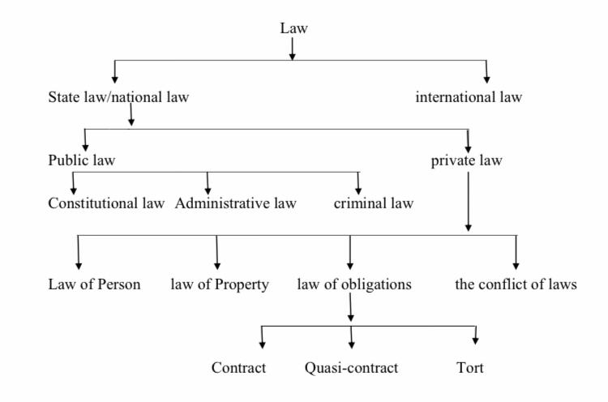

**Conclusion:**

The above classification of law has many defects. Many of the classes do not exist in many legal system at all some branches of law which has developed in recent years cannot be put under any one class exclusively. Therefore, the above classification is neither universal nor exhaustive. Many other Jurists have made classifications based on different principles. But these too have been made keeping in view the law of a particular nation; therefore, they are not satisfactory and have no wide application. In modern times, new branches of law are fastly growing and developing. With the change in the concept of the State and law many branches of private law have shifted and have become part of the public law. Under these circumstances it is necessary to make a comprehensive and complete classification which might cover the recent developments of law.